**EMPLOYEE DEPARTMENT ANALYSIS**

1. Create the Employee Table as per the Below Data Provided

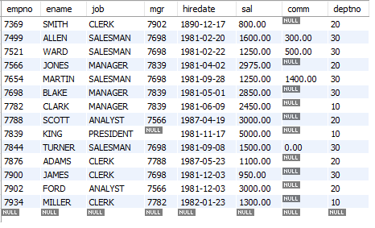

**Note :** Ensure the Salary cannot be Less then Negative or Zero

Deptno Should be foreign key. Referring to the Dept dept Table created in Step 2

Empno cannot be null or Duplicate.

Default Job should be Clerk

1. Create the Dept Table as below

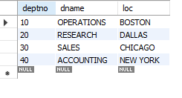

1. List the Names and salary of the employee whose salary is greater than 1000
2. List the details of the employees who have joined before end of September 81.
3. List Employee Names having I as second character.
4. List Employee Name, Salary, Allowances (40% of Sal), P.F. (10 % of Sal) and Net Salary. Also assign the alias name for the columns
5. List Employee Names with designations who does not report to anybody
6. List Empno, Ename and Salary in the ascending order of salary.
7. How many jobs are available in the Organization ?
8. Determine total payable salary of salesman category
9. List average monthly salary for each job within each department
10. Use the Same EMP and DEPT table used in the Case study to Display EMPNAME, SALARY and DEPTNAME in which the employee is working.
11. Create the Job Grades Table as below

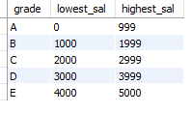

1. Display the last name, salary and Corresponding Grade.
2. Display the Emp name and the Manager name under whom the Employee works in the below format .

**Emp Report to Mgr**.

1. Display Empname and Total sal where Total Sal (sal + Comm)
2. Display Empname and Sal whose empno is a odd number
3. Display Empname , Rank of sal in Organisation , Rank of Sal in their department
4. Display Top 3 Empnames based on their Salary
5. Display Empname who has highest Salary in Each Department.